
Savitribai Phule Pune University
Interdisciplinary School of Scientific Computing (ISSC)

Test - V

Course No. : SC - 104

Title : Foundation of Scientific Computing - II

Date : 15/10/2018
Time : 4:00 pm to 4:30 pm Marks : 10
______________________________________________________________________________

Q.1. Find the area bounded by the curve (3)

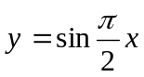 and the line 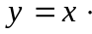

Q.2 Using integration compute the surface area of the sphere of radius (3)

Q.3 The area bounded by the curve 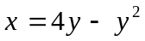 and the 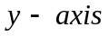 is rotated to generate (4)
solid of revolution. Find the volume of this solid when the area is rotated around

- (b) 



